**COEN 317**

**Microprocessor Systems**

**EXPERIMENT #4**

**Interrupts with the AXI Timer**

**Name : Nicholas Gattuso**

**Section : U-UI**

"I certify that this submission is my original work and meets the Faculty’s Expectations of Originality",

# Objectives

The objectives of the lab are to become familiar with the interrupts using the AXI timer on the Xilinx ZC702 development board. Additionally, it is also to gain experience with the PlanAhead tools, the Xilinx Platform Studio, and the SDK.

# Introduction

# In this lab, we are introduced to the interrupt structure of the ARM processor. An interrupt is important for processors as it allows the processor to halt its current execution to service the interrupt. Usually, interrupts come from a request for a service with a higher priority. Therefore, it’s important for the processor to service the request as soon as possible.

In the previous lab, we were introduced to the AXI Timer. A quick recap on the previous lab: the timer is a timer module that counts the clock sequence. We’ve seen three different modes to use the timer in. In this lab, we learn that the two registers have an interrupt on the timer interval.

For the lab, we will generate a pulse on the external Interrupt port. Additionally, we wil connect the Interrupt port to the Interrupt request pin of the ARM processor.

For more information, please refer to the lab manual.

# Results

The first part can be done by following the steps given in the lab manual. The following is the main.cc code that was provided to us by Ted:

/*

* Copyright (c) 2009 Xilinx, Inc. All rights reserved.

*

* Xilinx, Inc.

* XILINX IS PROVIDING THIS DESIGN, CODE, OR INFORMATION "AS IS" AS A

* COURTESY TO YOU. BY PROVIDING THIS DESIGN, CODE, OR INFORMATION AS

* ONE POSSIBLE IMPLEMENTATION OF THIS FEATURE, APPLICATION OR

* STANDARD, XILINX IS MAKING NO REPRESENTATION THAT THIS IMPLEMENTATION

* IS FREE FROM ANY CLAIMS OF INFRINGEMENT, AND YOU ARE RESPONSIBLE

* FOR OBTAINING ANY RIGHTS YOU MAY REQUIRE FOR YOUR IMPLEMENTATION.

* XILINX EXPRESSLY DISCLAIMS ANY WARRANTY WHATSOEVER WITH RESPECT TO

* THE ADEQUACY OF THE IMPLEMENTATION, INCLUDING BUT NOT LIMITED TO

* ANY WARRANTIES OR REPRESENTATIONS THAT THIS IMPLEMENTATION IS FREE

* FROM CLAIMS OF INFRINGEMENT, IMPLIED WARRANTIES OF MERCHANTABILITY

* AND FITNESS FOR A PARTICULAR PURPOSE.

*

*/

#include <iostream>

using namespace std;

#include "xparameters.h"

#include "xil_types.h"

#include "xtmrctr.h"

#include "xil_io.h"

#include "xil_exception.h"

#include "xscugic.h"

#include <stdio.h>

/* Instance of the Interrupt Controller */

XScuGic InterruptController;

/* The configuration parameters of the controller */

static XScuGic_Config *GicConfig;

// Timer Instance

XTmrCtr TimerInstancePtr;

int test = 0;

void Timer_InterruptHandler(void)

{

cout << "I am the interrupt handler" << endl;

}

int SetUpInterruptSystem(XScuGic *XScuGicInstancePtr)

{

/*

* Connect the interrupt controller interrupt handler to the hardware

* interrupt handling logic in the ARM processor.

*/

Xil_ExceptionRegisterHandler(XIL_EXCEPTION_ID_INT,

(Xil_ExceptionHandler) XScuGic_InterruptHandler,

XScuGicInstancePtr);

/*

* Enable interrupts in the ARM

*/

Xil_ExceptionEnable();

return XST_SUCCESS;

}

int ScuGicInterrupt_Init(u16 DeviceId,XTmrCtr *TimerInstancePtr)

{

int Status;

/*

* Initialize the interrupt controller driver so that it is ready to

* use.

* */

GicConfig = XScuGic_LookupConfig(DeviceId);

if (NULL == GicConfig)

{

return XST_FAILURE;

}

Status = XScuGic_CfgInitialize(&InterruptController, GicConfig,

GicConfig->CpuBaseAddress);

if (Status != XST_SUCCESS)

{

return XST_FAILURE;

}

/*

* Setup the Interrupt System

* */

Status = SetUpInterruptSystem(&InterruptController);

if (Status != XST_SUCCESS)

{

return XST_FAILURE;

}

// add this line to fix the interrupt only running once

// Nov. 15, 2017

// solution found by Anthony Fiorito on Xilinx Forum

XScuGic_CPUWriteReg(&InterruptController, XSCUGIC_EOI_OFFSET, XPAR_FABRIC_AXI_TIMER_0_INTERRUPT_INTR);

/*

* Connect a device driver handler that will be called when an

* interrupt for the device occurs, the device driver handler performs

* the specific interrupt processing for the device

*/

Status = XScuGic_Connect(&InterruptController,

XPAR_FABRIC_AXI_TIMER_0_INTERRUPT_INTR,

(Xil_ExceptionHandler)XTmrCtr_InterruptHandler,

(void *)TimerInstancePtr);

if (Status != XST_SUCCESS)

{

return XST_FAILURE;

}

/*

* Enable the interrupt for the device and then cause (simulate) an

* interrupt so the handlers will be called

*/

XScuGic_Enable(&InterruptController, XPAR_FABRIC_AXI_TIMER_0_INTERRUPT_INTR);

return XST_SUCCESS;

}

int main()

{

cout << "Application starts " << endl;

int xStatus;

//~~~~~~~~~~~~~~~~~~~~~~~~~~~~~~~~~~~~~~~~~~~~~~~~~~~~~~~~~~~~~~~~~~~~~~~~~~~

//Step-1 :AXI Timer Initialization

//~~~~~~~~~~~~~~~~~~~~~~~~~~~~~~~~~~~~~~~~~~~~~~~~~~~~~~~~~~~~~~~~~~~~~~~~~~~

xStatus = XTmrCtr_Initialize(&TimerInstancePtr, XPAR_AXI_TIMER_0_DEVICE_ID);

if(XST_SUCCESS != xStatus)

{

cout << "TIMER INIT FAILED " << endl;

if(xStatus == XST_DEVICE_IS_STARTED)

{

cout << "TIMER has already started" << endl;

cout << "Please power cycle your board, and re-program the bitstream" << endl;

}

return 1;

}

//~~~~~~~~~~~~~~~~~~~~~~~~~~~~~~~~~~~~~~~~~~~~~~~~~~~~~~~~~~~~~~~~~~~~~~~~~~~

//Step-2 :Set Timer Handler

//~~~~~~~~~~~~~~~~~~~~~~~~~~~~~~~~~~~~~~~~~~~~~~~~~~~~~~~~~~~~~~~~~~~~~~~~~~~

//

// cast second argument to data type XTmrCtr_Handler since in gcc it gave a warning

// and with g++ for the C++ version it resulted in an error

XTmrCtr_SetHandler(&TimerInstancePtr, (XTmrCtr_Handler)Timer_InterruptHandler, &TimerInstancePtr);

// intialize time pointer with value from xparameters.h file

unsigned int* timer_ptr = (unsigned int* )XPAR_AXI_TIMER_0_BASEADDR;

//~~~~~~~~~~~~~~~~~~~~~~~~~~~~~~~~~~~~~~~~~~~~~~~~~~~~~~~~~~~~~~~~~~~~~~~~~~~

//Step-3 :load the reset value

//~~~~~~~~~~~~~~~~~~~~~~~~~~~~~~~~~~~~~~~~~~~~~~~~~~~~~~~~~~~~~~~~~~~~~~~~~~~

*(timer_ptr+ 1) = 0xffffff00;

//~~~~~~~~~~~~~~~~~~~~~~~~~~~~~~~~~~~~~~~~~~~~~~~~~~~~~~~~~~~~~~~~~~~~~~~~~~~

//Step-4 : set the timer options

//~~~~~~~~~~~~~~~~~~~~~~~~~~~~~~~~~~~~~~~~~~~~~~~~~~~~~~~~~~~~~~~~~~~~~~~~~~~

// from xparameters.h file #define XPAR_AXI_TIMER_0_BASEADDR 0x42800000

// Configure timer in generate mode, count up, interrupt enabled

// with autoreload of load register

*(timer_ptr) = 0x0f4 ;

//~~~~~~~~~~~~~~~~~~~~~~~~~~~~~~~~~~~~~~~~~~~~~~~~~~~~~~~~~~~~~~~~~~~~~~~~~~~

//Step-5 : SCUGIC interrupt controller Initialization

//Registration of the Timer ISR

//~~~~~~~~~~~~~~~~~~~~~~~~~~~~~~~~~~~~~~~~~~~~~~~~~~~~~~~~~~~~~~~~~~~~~~~~~~~

xStatus=

ScuGicInterrupt_Init(XPAR_PS7_SCUGIC_0_DEVICE_ID, &TimerInstancePtr);

if(XST_SUCCESS != xStatus)

{

cout << " :( SCUGIC INIT FAILED )" << endl;

return 1;

}

// Beginning of our main code

//We want to control when the timer starts

char input;

cout << "Press any key to start the timer" << endl;

cin >> input ;

cout << "You pressed "<< input << endl;

cout << "Enabling the timer to start" << endl;

*(timer_ptr) = 0x0d4 ; // deassert the load 5 to allow the timer to start counting

// let timer run forever generating periodic interrupts

while( 1)

{

// // wait forever and let the timer generate periodic interrupts

}

return 0;

}

We can analyze the main.cc code to understand how the software configures the interrupt controller and handles the interrupt. To begin, we have three global timer variables: a instance for the interrupt controller, configuration for the controller, and a timer instance. These are global because we’d like to access them in the functions outside of the main. In the There are also three functions that are used to handle the interrupt, initialize the interrupt controller driver, and connect the interrupt controller. I won’t go into too much detail on what is going on within the functions. Instead, I’m going to move towards the important sections of the code that are worth noting.

In step 3 and step 4, the timer pointer in being set to a specific value. These values are determined from the AXI Timer manual that we saw from the last lab. Therefore, to determine the proper value, we need to know which bit has to be 1. Additionally, we’d need to look at the bits from the manual to determine the deassert value for the timer pointer.

The following is the result from running the code:

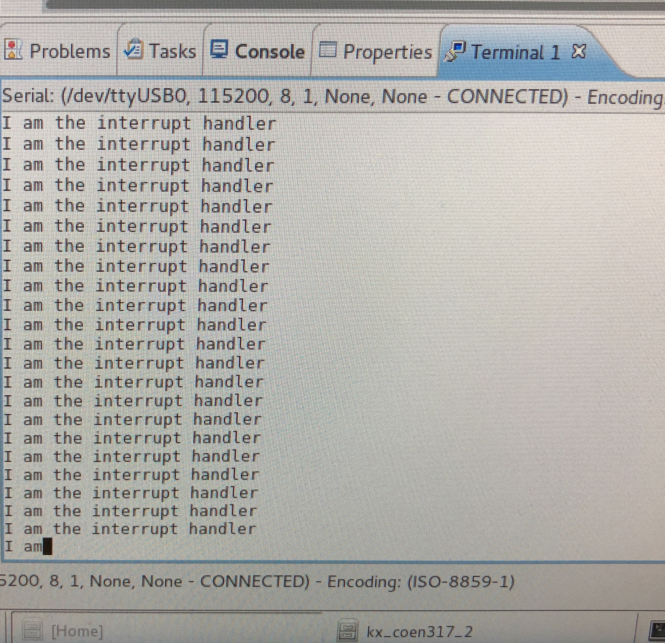

# Questions

The AXI timer only has 1 interrupt signal but contains two timers. For the reason, we’d need to check which timer is generating the interrupt. Firstly, the interrupt signal is the OR of the interrupts from the two timers. This is determined using the TINT bit. To get the necessary changes, we need to modify two areas from the previous code. Firstly, in the main, we need to create setup the second timer. Secondly, in the interrupt handler, we modify it to stop the timers by setting the 8th bit to 0 and then read which timer contains the interrupt. The following is the modified code:

#include <iostream>

using namespace std;

#include "xparameters.h"

#include "xil_types.h"

#include "xtmrctr.h"

#include "xil_io.h"

#include "xil_exception.h"

#include "xscugic.h"

#include <stdio.h>

/* Instance of the Interrupt Controller */

XScuGic InterruptController;

/* The configuration parameters of the controller */

static XScuGic_Config *GicConfig;

// Timer Instance

XTmrCtr TimerInstancePtr;

int test = 0;

void Timer_InterruptHandler(void)

{

//define the timer pointer

unsigned int* timer_ptr = (unsigned int*)XPAR_AXI_TIMER_0_BASEADDR;

cout << "Value for first:" << *(timer_ptr) << " and second: " << *(timer_ptr + 4) << endl;

//stop both timers by setting the 8th bit to 0

*(timer_ptr) = 0x054;

*(timer_ptr + 4) = 0x054;

cout << "Value for first:" << *(timer_ptr) << " and second: " << *(timer_ptr + 4) << endl;

//read the value from the timer and determine which one called the interrupt

if((*(timer_ptr) == 0x84))

{

cout << "the interrupt has been called by timer_ptr + 4" << endl;

}

else{ cout << "the interrupt has been called by timer_ptr" << endl;}

//prompt user to enter a value to begin the timer

char input;

cout << "Press any key to start the timer" << endl;

cin >> input ;

cout << "You pressed "<< input << endl;

cout << "Enabling the timer to start" << endl;

*(timer_ptr) = 0x0d4 ;

*(timer_ptr + 4) = 0x0d4 ;

}

int SetUpInterruptSystem(XScuGic *XScuGicInstancePtr)

{

/*

* Connect the interrupt controller interrupt handler to the hardware

* interrupt handling logic in the ARM processor.

*/

Xil_ExceptionRegisterHandler(XIL_EXCEPTION_ID_INT,

(Xil_ExceptionHandler) XScuGic_InterruptHandler,

XScuGicInstancePtr);

/*

* Enable interrupts in the ARM

*/

Xil_ExceptionEnable();

return XST_SUCCESS;

}

int ScuGicInterrupt_Init(u16 DeviceId,XTmrCtr *TimerInstancePtr)

{

int Status;

/*

* Initialize the interrupt controller driver so that it is ready to

* use.

* */

GicConfig = XScuGic_LookupConfig(DeviceId);

if (NULL == GicConfig)

{

return XST_FAILURE;

}

Status = XScuGic_CfgInitialize(&InterruptController, GicConfig,

GicConfig->CpuBaseAddress);

if (Status != XST_SUCCESS)

{

return XST_FAILURE;

}

/*

* Setup the Interrupt System

* */

Status = SetUpInterruptSystem(&InterruptController);

if (Status != XST_SUCCESS)

{

return XST_FAILURE;

}

// add this line to fix the interrupt only running once

// Nov. 15, 2017

// solution found by Anthony Fiorito on Xilinx Forum

XScuGic_CPUWriteReg(&InterruptController, XSCUGIC_EOI_OFFSET, XPAR_FABRIC_AXI_TIMER_0_INTERRUPT_INTR);

/*

* Connect a device driver handler that will be called when an

* interrupt for the device occurs, the device driver handler performs

* the specific interrupt processing for the device

*/

Status = XScuGic_Connect(&InterruptController,

XPAR_FABRIC_AXI_TIMER_0_INTERRUPT_INTR,

(Xil_ExceptionHandler)XTmrCtr_InterruptHandler,

(void *)TimerInstancePtr);

if (Status != XST_SUCCESS)

{

return XST_FAILURE;

}

/*

* Enable the interrupt for the device and then cause (simulate) an

* interrupt so the handlers will be called

*/

XScuGic_Enable(&InterruptController, XPAR_FABRIC_AXI_TIMER_0_INTERRUPT_INTR);

return XST_SUCCESS;

}

int main()

{

cout << "Application starts " << endl;

int xStatus;

//~~~~~~~~~~~~~~~~~~~~~~~~~~~~~~~~~~~~~~~~~~~~~~~~~~~~~~~~~~~~~~~~~~~~~~~~~~~

//Step-1 :AXI Timer Initialization

//~~~~~~~~~~~~~~~~~~~~~~~~~~~~~~~~~~~~~~~~~~~~~~~~~~~~~~~~~~~~~~~~~~~~~~~~~~~

xStatus = XTmrCtr_Initialize(&TimerInstancePtr, XPAR_AXI_TIMER_0_DEVICE_ID);

if(XST_SUCCESS != xStatus)

{

cout << "TIMER INIT FAILED " << endl;

if(xStatus == XST_DEVICE_IS_STARTED)

{

cout << "TIMER has already started" << endl;

cout << "Please power cycle your board, and re-program the bitstream" << endl;

}

return 1;

}

//~~~~~~~~~~~~~~~~~~~~~~~~~~~~~~~~~~~~~~~~~~~~~~~~~~~~~~~~~~~~~~~~~~~~~~~~~~~

//Step-2 :Set Timer Handler

//~~~~~~~~~~~~~~~~~~~~~~~~~~~~~~~~~~~~~~~~~~~~~~~~~~~~~~~~~~~~~~~~~~~~~~~~~~~

//

// cast second argument to data type XTmrCtr_Handler since in gcc it gave a warning

// and with g++ for the C++ version it resulted in an error

XTmrCtr_SetHandler(&TimerInstancePtr, (XTmrCtr_Handler)Timer_InterruptHandler, &TimerInstancePtr);

// intialize time pointer with value from xparameters.h file

unsigned int* timer_ptr = (unsigned int* )XPAR_AXI_TIMER_0_BASEADDR;

//~~~~~~~~~~~~~~~~~~~~~~~~~~~~~~~~~~~~~~~~~~~~~~~~~~~~~~~~~~~~~~~~~~~~~~~~~~~

//Step-3 :load the reset value

//~~~~~~~~~~~~~~~~~~~~~~~~~~~~~~~~~~~~~~~~~~~~~~~~~~~~~~~~~~~~~~~~~~~~~~~~~~~

*(timer_ptr+ 1) = 0xffffff00;

*(timer_ptr+ 5) = 0xffffff00;

//~~~~~~~~~~~~~~~~~~~~~~~~~~~~~~~~~~~~~~~~~~~~~~~~~~~~~~~~~~~~~~~~~~~~~~~~~~~

//Step-4 : set the timer options

//~~~~~~~~~~~~~~~~~~~~~~~~~~~~~~~~~~~~~~~~~~~~~~~~~~~~~~~~~~~~~~~~~~~~~~~~~~~

// from xparameters.h file #define XPAR_AXI_TIMER_0_BASEADDR 0x42800000

// Configure timer in generate mode, count up, interrupt enabled

// with autoreload of load register

*(timer_ptr) = 0x0f4 ;

*(timer_ptr + 4) = 0x0f4 ;

//~~~~~~~~~~~~~~~~~~~~~~~~~~~~~~~~~~~~~~~~~~~~~~~~~~~~~~~~~~~~~~~~~~~~~~~~~~~

//Step-5 : SCUGIC interrupt controller Initialization

//Registration of the Timer ISR

//~~~~~~~~~~~~~~~~~~~~~~~~~~~~~~~~~~~~~~~~~~~~~~~~~~~~~~~~~~~~~~~~~~~~~~~~~~~

xStatus=

ScuGicInterrupt_Init(XPAR_PS7_SCUGIC_0_DEVICE_ID, &TimerInstancePtr);

if(XST_SUCCESS != xStatus)

{

cout << " :( SCUGIC INIT FAILED )" << endl;

return 1;

}

// Beginning of our main code

//We want to control when the timer starts

char input;

cout << "Press any key to start the timer" << endl;

cin >> input ;

cout << "You pressed "<< input << endl;

cout << "Enabling the timer to start" << endl;

*(timer_ptr) = 0x0d4 ; // deassert the load 5 to allow the timer to start counting

*(timer_ptr + 4) = 0x0d4 ;

// let timer run forever generating periodic interrupts

while( 1)

{

// // wait forever and let the timer generate periodic interrupts

}

return 0;

}

The following is the result from running the modified code:

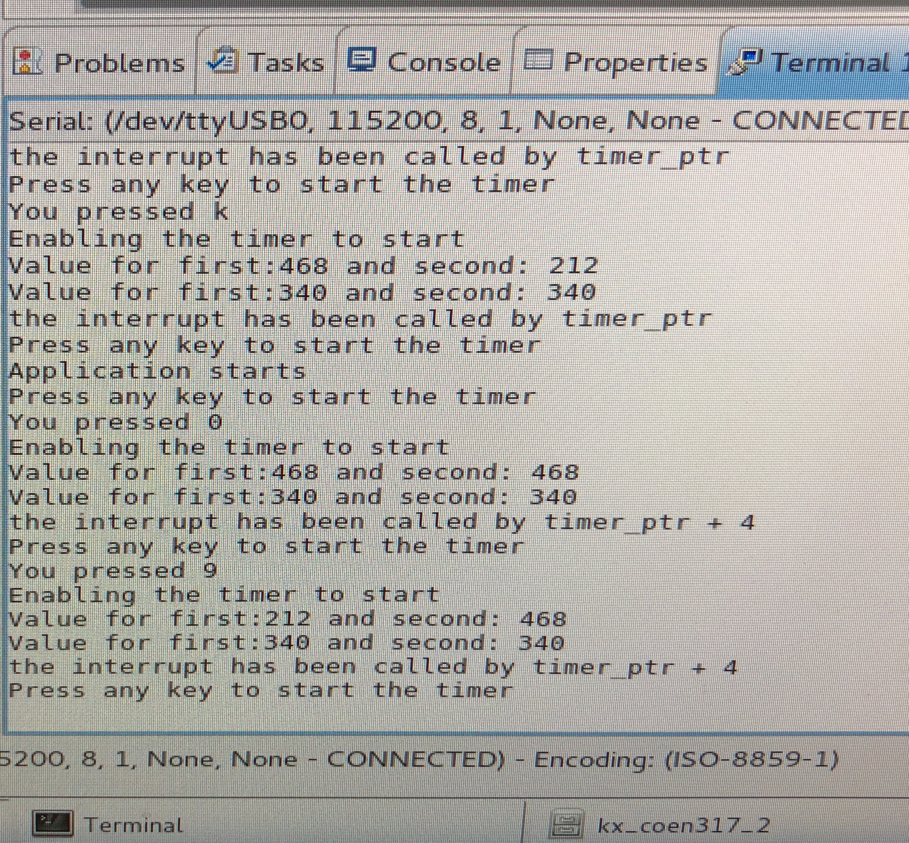

# Conclusion

In conclusion, the objectives of the lab were met. I managed to gain experience using interrupts with the AXI Timer. Additionally, I managed to determine which timer causes the interrupt.